**Appendix AND SAMPLE DATA**

Appendix 1 – Test data:

* Select “Activity and Volunteer Information” to add or edit new volunteer or activity into the database.
  + Add new Volunteer – any valid inputs with involvement and training IDs greater than 1.
  + Edit Volunteer – Choose the volunteer names from the dropdown.
  + Add activity – Choose any volunteer ID from 1,3,4,5.. and so on.
  + Edit Activity - Choose the volunteer names from the dropdown.
  + Select “Go to Homepage” to go back to the main dashboard.
* Select Verify Age. Input volunteer ID (1,3,4,5 or any valid ID)
  + 1 – for above 18
  + 3 – for below 18
* Select “Generate Volunteer’s Involvement Time”.
  + Sample input volunteer ID – 1; input involvement ID – 1; start date “12-01-1999” and end date “25-06-2020”.
* Select “Identify volunteer on or above the given ID”
  + Give a valid Training ID – e.g. 1 (2,3,4,5)
* Select “Search for Emergency Contact”
  + Input a valid input volunteer ID e.g. 1 (3,4,5,6…)

Appendix 2 – MAIN DASHBOARD

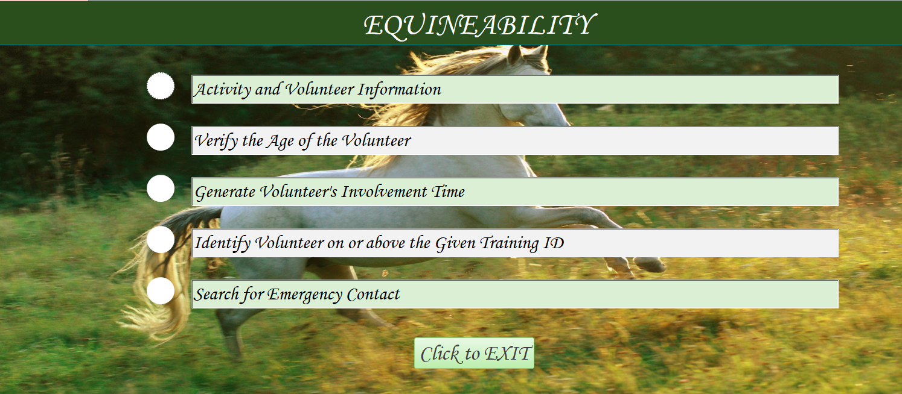

Appendix 3 – Volunteer Information DASHBOARD

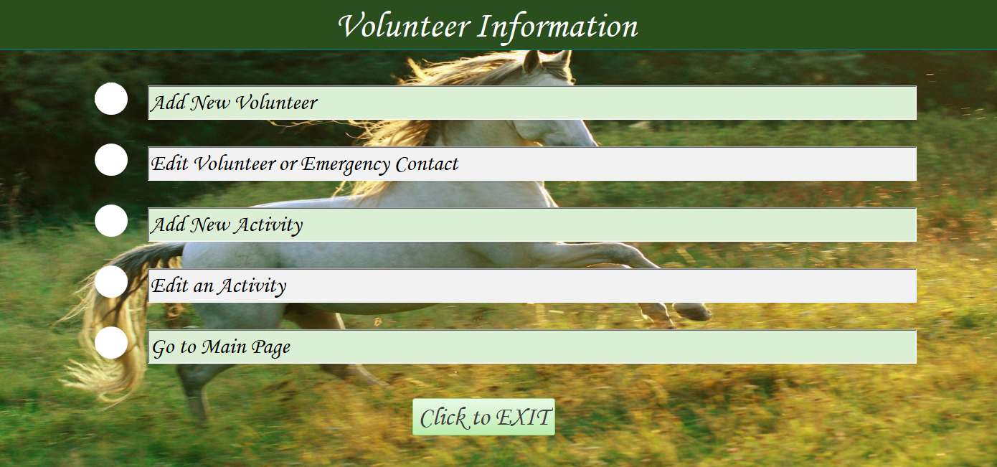

Appendix 4 – Sample FORM

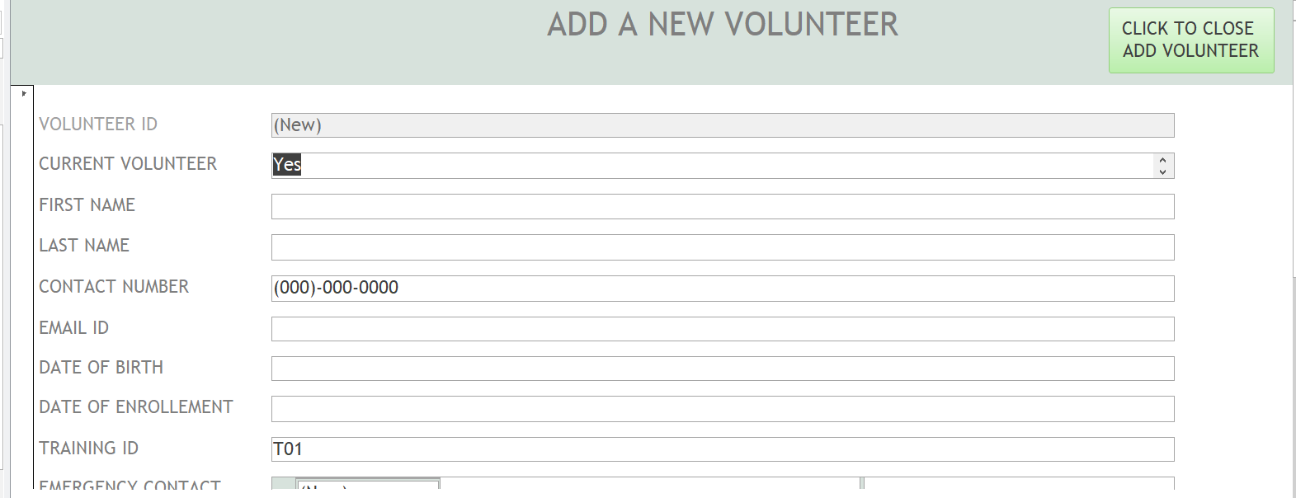

Appendix 5 – Sample Report

